- *!v!e111/Je1· Fi,·111 (J/.*

**K rou**

**Independent quality assured professionals**

Chartered Accountants

**CONDENSED INTERIM FINANCIAL**

**INFORMATION**

**OF**

•

**ORSPINNIN**

**LI ITED**

**ILLS**

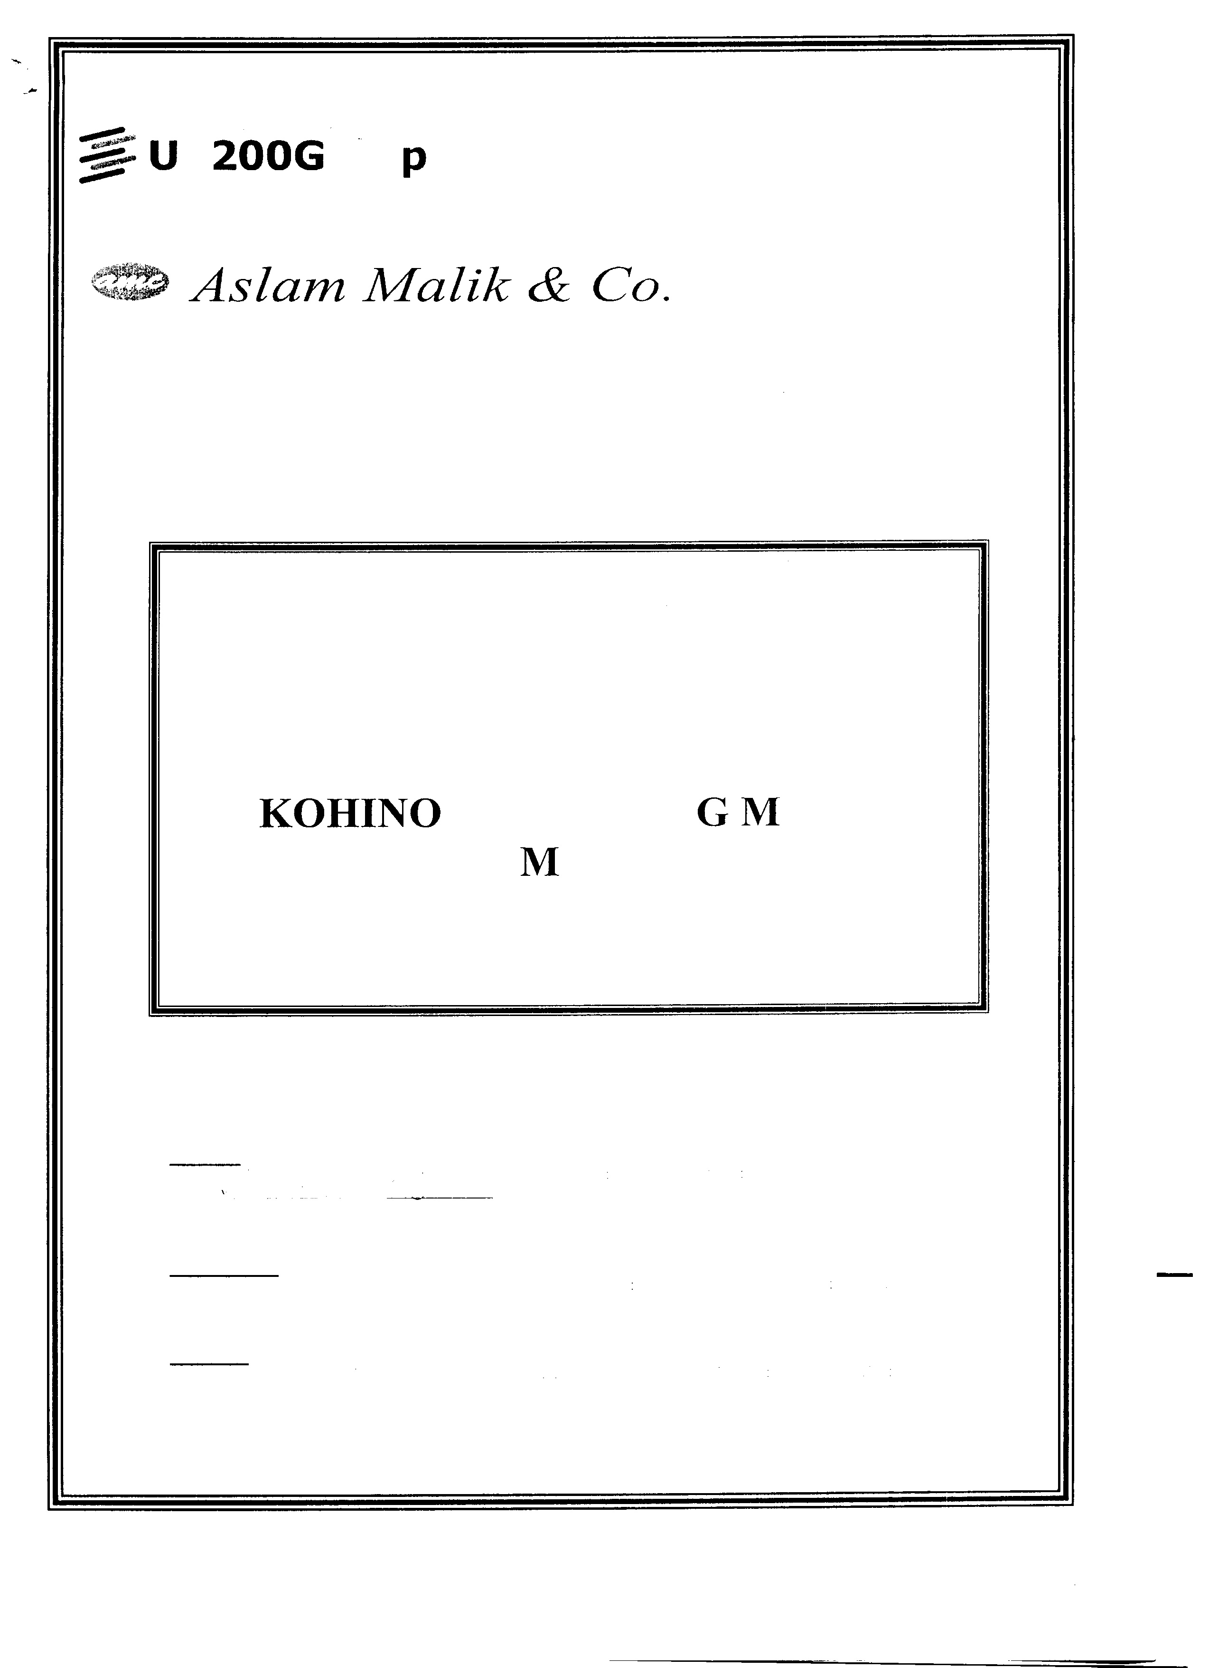

**FOR THE HALF YEAR ENDED DECEMBER 31, 2014**

**Lahore:**

Suite # 19, First Floor, Central Plaza.New Garden To,v11, Lahore. Pl1011e 042-35858(,93-·I Fax 35856019

Web: wv, w. as I a111111a I I k. C<)111E111a i I: i11 *fo(ivas* la1111n,1I i k

**Islamabad:**

House # 726, Street 34, Margalla To,v11. Off Muree Road, Islamabad. Phone 051-28-IIJ-187-88. 2821185. Fax ll5 l-28-11)486

**Karachi:**

602-B 6'" Floor. Business & F111a11ce Centre, Opposite SBP I I Chundrigar Road, Karachi. l'l1011e ()21-32412212 1:a, (121-

32472235

*- Member Firm of*

� **UK200Group**

- Independent quality assured professionals

Aslam Malik & Co.

Chartered Accountants

Phone : +92-42-35858693-35858694

: +92-42-35856819

Fax : +92-42-35856019

e-mail : [aslammalik@brain.net.pk](mailto:aslammalik@brain.net.pk) [info@aslammalik.com](mailto:info@aslammalik.com)

web : [www.aslammalik.com](http://www.aslammalik.com)

Suite# 18-19 First Floor, Central Plaza, Civic Centre,

New Garden Town, Lahore-Pakistan.

AUDITORS' REPORT TO l'HE MEMBERS

ON REVIEW OF CONDENSED INTERIM FINANCIAL INFOflMA'fION

Introduction

We have reviewed the accompanying condensed interim balance sheet of Kohinoor Spinning Mills Limited (''The Company") as at Decernber 31, 2014 and the related condensed interim profit and loss account. condensed interim statement of comprehensive income, condensed interim cash flow statement and condensed interim statement of changes in equity together with the notes to1·111i11g part thereof (here-in-after referred to ,is the "condensed interim financial information") for the half year then ended. Management is responsible for the preparation and presentation of this condensed interim financial information in accordance with approved accounting standards as applicable in Pakistan for interim financial reporting. OL1r responsibility is to express ,1 conclusion on this condensed interim financial information based on 0L1r review. The figures of tl1e condensed interim profit and loss account and condensed interim statement of comprehensive income tor the quarters ended December 31, 2014 and 2013 have not been reviewed, as we are required to review only the cumulative figures

tor tl1e half year ended December 31, 2014.

•

Scope of Review

We conducted our review in accordance with International Standards 011 Review Engagements *2<1* I 0. "Review lit· interim financial information Performed by the Independent Auditor of the Entity". *A* review of· condensed interim financial information consist of making inquiries, primarily of persons responsible for financial and accounting matters, and applying analytical and other review procedures. *A* review is substantial ly less i11 scope than an aud it conducted in accordance with l nternational Standards 011 *A* Lid iti 11g and con seq uent I y does not enable us to obtain assurance that we would become aware of' all significant matters that might l,e identified in ,111 audit. Accordingly, we do not express an audit opinion,

Conclusion

Based on our review, nothing has come to 0L1r attention that causes LIS to believe that the accompanying condensed interim financial information as of and tor the half year ended December 31. 2014 is not prepared, i11 all material respects, in accordance with approved accounting standards as applicable i11 Pakistan for interim

financial reporting.

Lahore.

Date: February 28, 2015

(Asli1111 Malil, & *C<i)*

Chartered Accountants

E11gage111e11t Partner

Mohammad Aslam Malik



Other Offices at:

Islamabad: House # 726, Street 34, Margalla Town, off Murree Road, Islamabad.

Tel: +92-51-2840487-88, Fax: +92-51-2840486

Karachi: Suite# 602-B, 6th Floor, Business & Finance Center, I.I. Chundrigar Road, Karachi

Tel:+ 92-21-32412212, 32443706 Fax: +92-21-32472235

•

***DIRECTORS' REPORT***

On behalf of the Directors of Kohinoor Spinning Mills Limited, it is my pleasure to present six months accounts for the period ended 31 December 2014.

Your Company has incurred a net loss of Rs. 50.407 million as compared to a net profit of Rs. 81.474 million for the corresponding period last year. This drastic change in result is mainly attributed to the carrying forward of costly opening cotton inventory, overall depressed sentiments of yarn market, and depreciation of US Dollar against Pak Rupee.

After raw material management, fuel and power availability have now become our most serious concern. The availability of WAPDA supplied electricity is erratic. During the period under review, we got electricity between 14 hours per day to 20 hours per day. These days, we are getting electricity from WAPDA on 24 hours basis. Gas supply is another conflicting matter between industry and Government. As per agreement with Sui Northern Gas Pipelines Limited (SNGPL), our captive power plant is entitled to 09- months per annum gas supply. However, this commitment is not being fulfilled by SNGPL.

In international market, oil prices have come down rapidly. The Government of Pakistan (GOP) has also reduced oil prices in Pakistan. However, GOP is reluctant to reduce electricity rates accordingly. The reduction in electricity rates for the month of December

2014 has been approved under the head ''Fuel Price Adjustment'' in February 2015 by

NEPRA. This reduction will take effect in the billing of March 2015. With better fuel and power supplies, our spinning industry has the potential to earn precious foreign exchange for the country. However, if situation is not improved, our country would lose competitive edge in spinning. If we want a strong industrial base, we need to rationalize our energy rates and ensure nonstop fuel and energy supply.

State Bank of Pakistan (SBP) has reduced discount rate by 100 basis points in last monetary policy. This is a step towards right direction. However, we still believe that SBP should drastically reduce discount rate to give Pakistani entrepreneurs some space to compete globally. All over the world, mark up rates are kept on lower side to encourage economic activities.

In the end, I assure you that the management of your company will continue its efforts to improve the overall performance of the Company through increased productivity, cost control and by devising innovative marketing strategies.



Lahore: February 28, 2015

0

Muhammad 14Q'aveed

( Chief Executive)

"Tl r

0 ,, o *(/)* )> --1 0 0 *(/)* r r z *(/)* )> - )> *Ch* m

Cl> ti) 0

, c: *zr* 0 , c Cl> c: ti)· 0

0 c:

0 "'

c: ::; 0 •

c,:r ::; �

0 , 0 0 ti) m' "O c:r ::, *er* 0 c: - Ill •

c ll) z

<-·

iil ;:i. 2

Q. ::0

-· IQ

z 0' c:

� Cl>

� zr .. c

--1

"' ::, '

Cl>

::0 �

"=O -· •

3 "' Q. "'

0 C1)

--1

ti) Cl>

s - -· -

Cl>

Cl> Cl> -· ro

0 a 0 0

,-·

'< •

::, -

Q. -,_

c -· - §

§ "'

z 0 Cl>

"O 3

Q-.

ti) m Cl> ,

z "'

::, -

IQ

-

ti)

c: • 0 -<

"' Cl>

•

Q.

ex,

m S'

0 ::, Q.

--1

ti)

0,"' 3-

::0 ::, ti) c:

::0 Cl> •

Ill )>

"C

z

(1)

- 0 -· Ill

N � G)

;::i.

c:r Cl>

,

,

c:r

-· -·

0 Cl> Q. 0 er

a - ,

• -· -

- r

"O

-

-

-

• 0.. z

- 0

0-· 0

ti) ::,

r m

, Q.

-

·

8 "'

§ o !il" c

-·

... 0

�

>-<

-

iil

0 "'

*zr*

Cl>

-

-IXJ

-· Cl>

ti)·

"'

'

ti)

"'

z Q.

0 ti)

- <.... *xr* <.... I::lsl

•

Q.

0

N :::, -

ti) 0 -

)>

Cl>

- ::,

::,

"O -·

r;: r;:

0, (1) m

- ti) :::,, ::, Cl> ::, ti) )>

."..'...

-

::,

-e -

"S,'' "'

--1

- ,

-

0

ti)

::0 -

*Ch*

...

-· ::,

�-·

IQ

"'

0 "O

r Ill r ::, CD Q. CD

IrXJ

0 ::,

::, ti)

cc cc

)> 0

z

- --1

c-:r m IQ

-

)>

IXJ

-

3

0

"' "'

Q.

0

s c ::, 0

,

ti)

,

- 0 •

::, •

C1)

ll)

:::,

ti) Cl>

::,

"'

...

rn -m--1

0

iil

r

"' -1 Q.

...

0

ti)

c: Cl>

*Ch* ti) "'

� "O �

C1)

"' -· c:

iil

� ·. �'

C1)

�· 0

0

ti)

c:

u. m

-· '

� *Ch*

:::,

(1) :ii:

:-:, ::, '< "' cc rn

:ii:

- Q.

*Ch* 0

0 c: 0

- --1

-· *er*

Cl>

0 • "O •

o.q..

ti) 0,

*iii*

0

8 s 0

*xr*· 8 8

0

,

-· :::,,

IQ -· -·

ti)

0 •

0 -· 0

ll)

:ii:

m

•

"-O

'"O

Cl>

::, � ti) �

ll) z

"' �-· ti) 0 - 0

::l. --1

*Ch*

::,

::, a a

.-.....

"' £ ::, ::,

::r

- ""<'

""<'

(1)

Cl> "*zr*'

:":,'-

"(1')

r"o' "al' "al'

t"l

0

"*Q*'*.*

"*Q*'*.*

:::,

0..

:,:, :,:,

(1)

*i;l*

"• '

CD

"'

"• '

CD'

"

(1)

0..

-s·

(.1..)

s�·

.s...·..

ll)

?�l·

l-l)

[

"0::,'- "0::,'-

z

0

S"

rn

0

c 0

z

c

C1)

0 m

0 ....

.... .... ....

-::0

C1) c

3 ::s z

3 .... .... .... .... .... .... C) .... en en c CT )> *Ch*

•

• • •

()0 w .... .... en en C) .... w C) .... .... C) C)

l�-l)-

u, .... .... .... .... C) .... .... N C) ()0 w u, u,

"O

C1)

C.1.) c

cm-

0 N u, t N ()0 .... w en u, C) N C) C) C1)

....

-..· z

• • • • • • • • • • • • • • Q.

N N ....

en C) en en C) C) rn

C1)

;:,

• • • • • • • • • • • • • - N

(..).0.

....

N ....

()0

w u,

w ....

en C) u, u, C) C)

•

Q. --1

w N u, en

co en

C) en en C) C)

.C..). m

w co en w en

•

en co w

:-:0

.... en

co w en

C) C)

()0 ()0 C) C)

....

u, co u,

C) C)

w w C) C)

:ii:

IXJ

)> 0

> :-c

"

z

...

... c... z

.... N

• •

... •

...

-..j

•... .... *a, a,*

-::0

::s

c:

)> m 0

c c

0 0

... e..x.., -..j 0,

N 0

0,

....

co (,>

C1)

0 (,> ex, 0, 0,

*Ch* ::0

• • • • • •

• • • •

• • • • • C1) C)

-..·

m .-,,

... *a,*

...

ex, co 0)

0 ex, ex, 0 0 "C w Q.

:c *Ch*

co (,> ex, 0...,. ex,

0, (,> co ex, ex, 0...,.

0,

......

(,> (,> -..j

*a,* co

0, (,> N

0 0 0 0 0

0 0 0 0 0

C1)

•

...).

C1)

--1 z

-..j

N

(,> (.,) -..j co

0,

*a,* ex,

0 N N 0 0 rn N Q. m z

0 (,> (.,) 0 0 -z

-

-..j *a,* N co

•

(,> 0 -..j

• • • • •

0 *a, a,* 0 0

.... )>

• •

' 0,

•

-..j

• • •

-..j (.,) 0,

• •co

co *a,*

•

.... co '

0 *a,*

*a,* 0 0

.,,

*Ch* G)

)> :ii:

--1 -

c r

m r

ti) iil 0 iil - - c 0 0 0 .. 0 *Ch* m r

C1)

::, Q. 0 ::0 IQ IQ IQ "C z

() -I r -I *(/) (/)* 0 r r r

z )>

0 *Ch*

"::'; a.

ti) 0 0 ::, ::, ::, 0

';<' iil

z

*h*

:ii: :ii:

ti) a. "'

Cl>

Q.

• "'

::0 C1)

Cl> Cl> Cl> c

, ,

�

--1

IXJ --1

::, Cl) ti) ro

-

--::,· ti) m ,

0

*Ch* m m

Q. "8

::,

,'

"'

-

::,

3 3 3

r

•

"C ::0

m

CT "-'·

Q.

ti)

<

CT

ti)

Q. -I

",'

-::,·

Q.

Cl> 0

"O ti)

"-' -

::0

..

::0

...

. c

Q.

Q. Cl> "O <

ti)

::,

';<'

c:r

•"'

"*::*'*r*

ti)

)>

ti) *Ch*

*Ch*

Cl>

0

"-'·

Ill

::,

"' Ill

z •

--1 N

ti) 0 m 3 )>

::s

...).

- ;::i.

::,

Cl>

::,

£ "'

--1

::s

Cl> Q. *Ch*

-....

::, "'

ti) ro "' *Ch*

£

3 "' ..c m

C1) *Ch* c

z

u c --1

"' , "-C· *Ch*

3

Cl>

u

Ill C1)

-

'< ::s

3

-

Cl>

:::,

"Il'l

:::, a. g_

*::r*

C,D

al

0

C-l)·

<

ti)

CT

- "' co ex,

CD

z

i

c

Cl)

*n*

)>

c-

-m-1

-c

•

.... en .... ....

•

w u,

....

.... ....

N -::0

C) c

•

Cl) c

3 ::s

.. )>

w

CT

Q.

en .... .... w ()0 C) .... N

.... ....

....

C) N

co .... .... w

.... w

w "C C1) c

.... C1) ·

...

en C) rn "

• • •

• • • • • • •

.... ....

•

- •....

u,

C)

co N

C) C)

....

u, u, u,

C) en

u,

C1)

,

w C) u,

en

• • •

--

• • w

C) w

• •g • •

u,

()0

•....

c.

....

en en ()0

- Ut- U'I u,

- - w u,

co N

u, ()0

.... N

"' C)

()0 co u,

w N C) ()0 ....

.... N

...

... ...

c...

-

c

• • •

(.,)

...

•co

::0

::s )>

.-.....j

....

-..j

*a,* -..j -..j

0....

... ... -..j c

C1)

w c.

c

-·

0 *a,* 0 co N

...

....

...

0 0,

ex, ex, •

co

...

.... .c.o. N

...

co *a, a,* N

"C C)

-rn N Q.

• • • • • • • • • • C1) S"

...

(,> (,> C)

-..j

-..j

co

*a,* N *a,*

0,

-..j 0,

.... 0

Cl)

....

0 0 co (,> ex, co co

... .... co

...

....

• • • • • • • • • • •

0 0, 0, ex, N 0, 0, 0 (,> N

ex, co -..j *a, a,* 0,

N 0 co

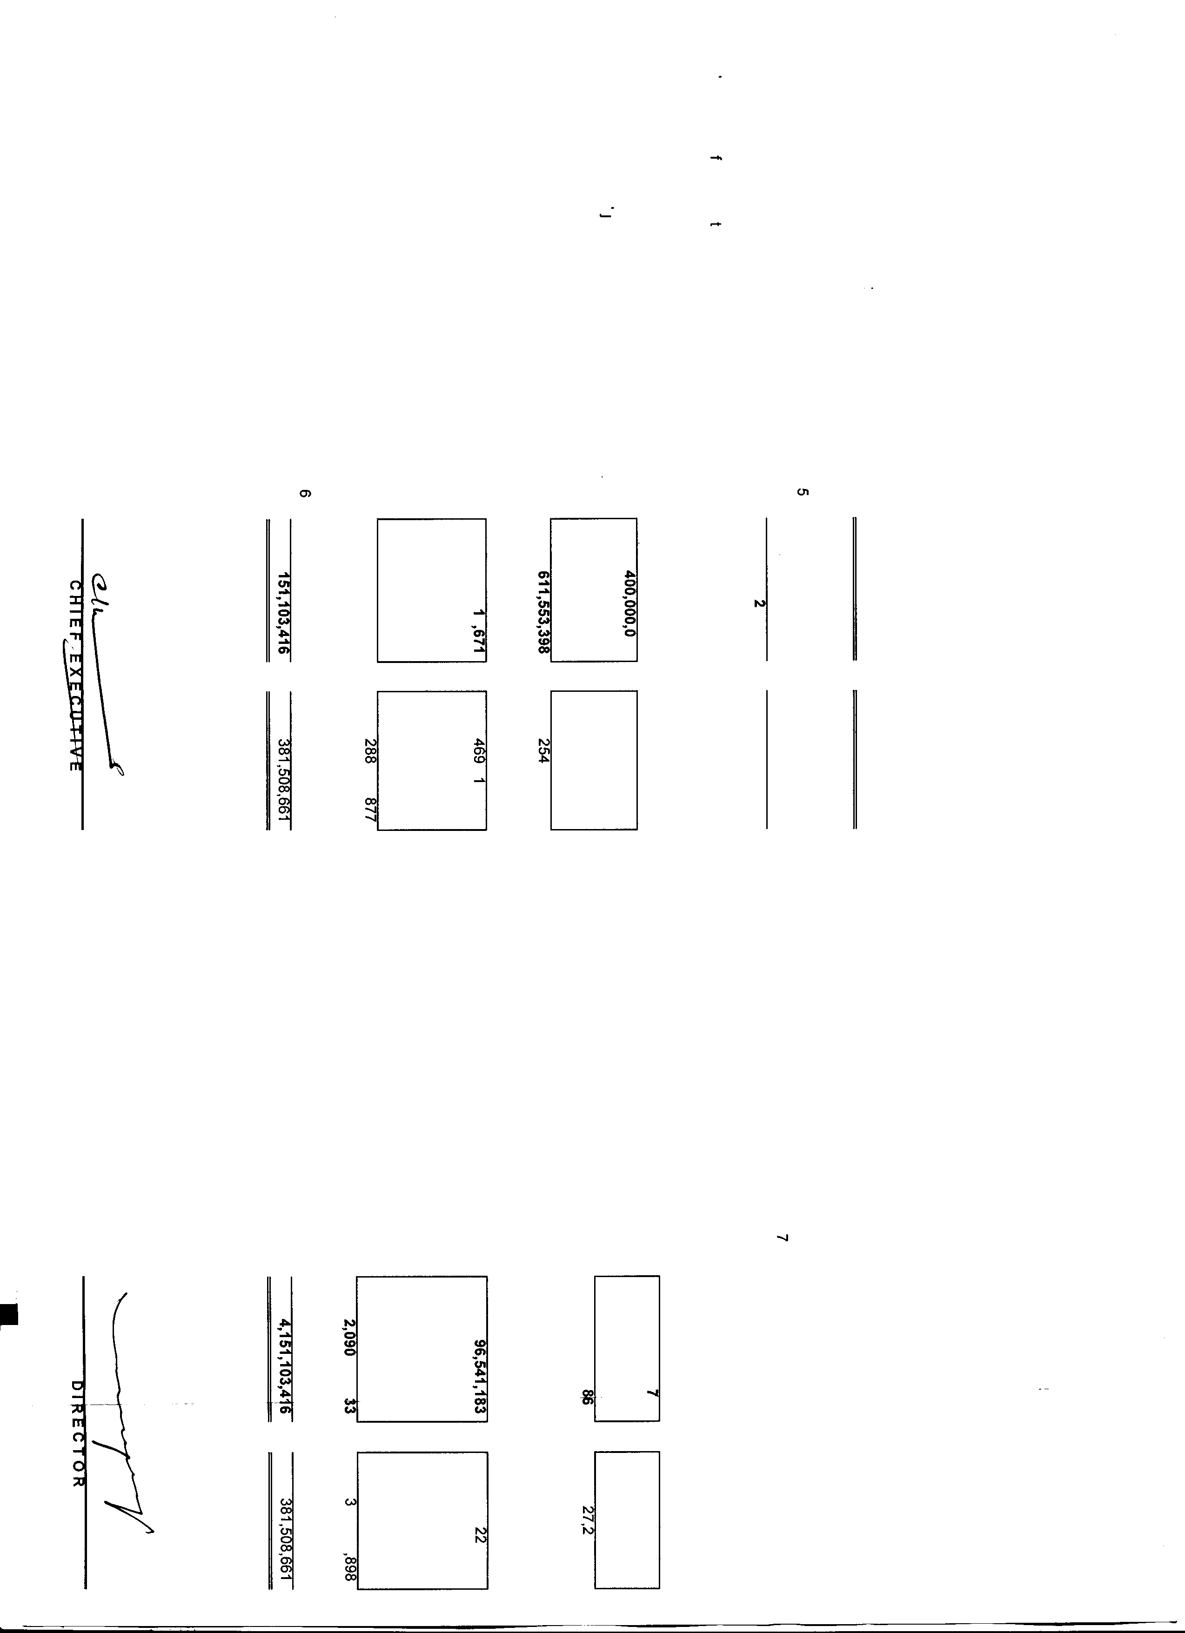

.... (,> co

co N 0 N

KOHINOOR SPINNING MILLS LIMITED

CONDENSED INTERIM PROFIT AND LOSS ACCOUNT (UN-AUDITED) FOR THE HALF YEAR ENDED DECEMBER 31, 2014

Half Year Ended Quarter Ended

Notes December 31,2014 (Rupees)

SALES - NET 3,040,737,955

December 31,2013 (Rupees)

3,412,831,226

December 31,2014 (Rupees)

1,535, 142,836

December 31,2013 (Rupees)

1,740,896,984

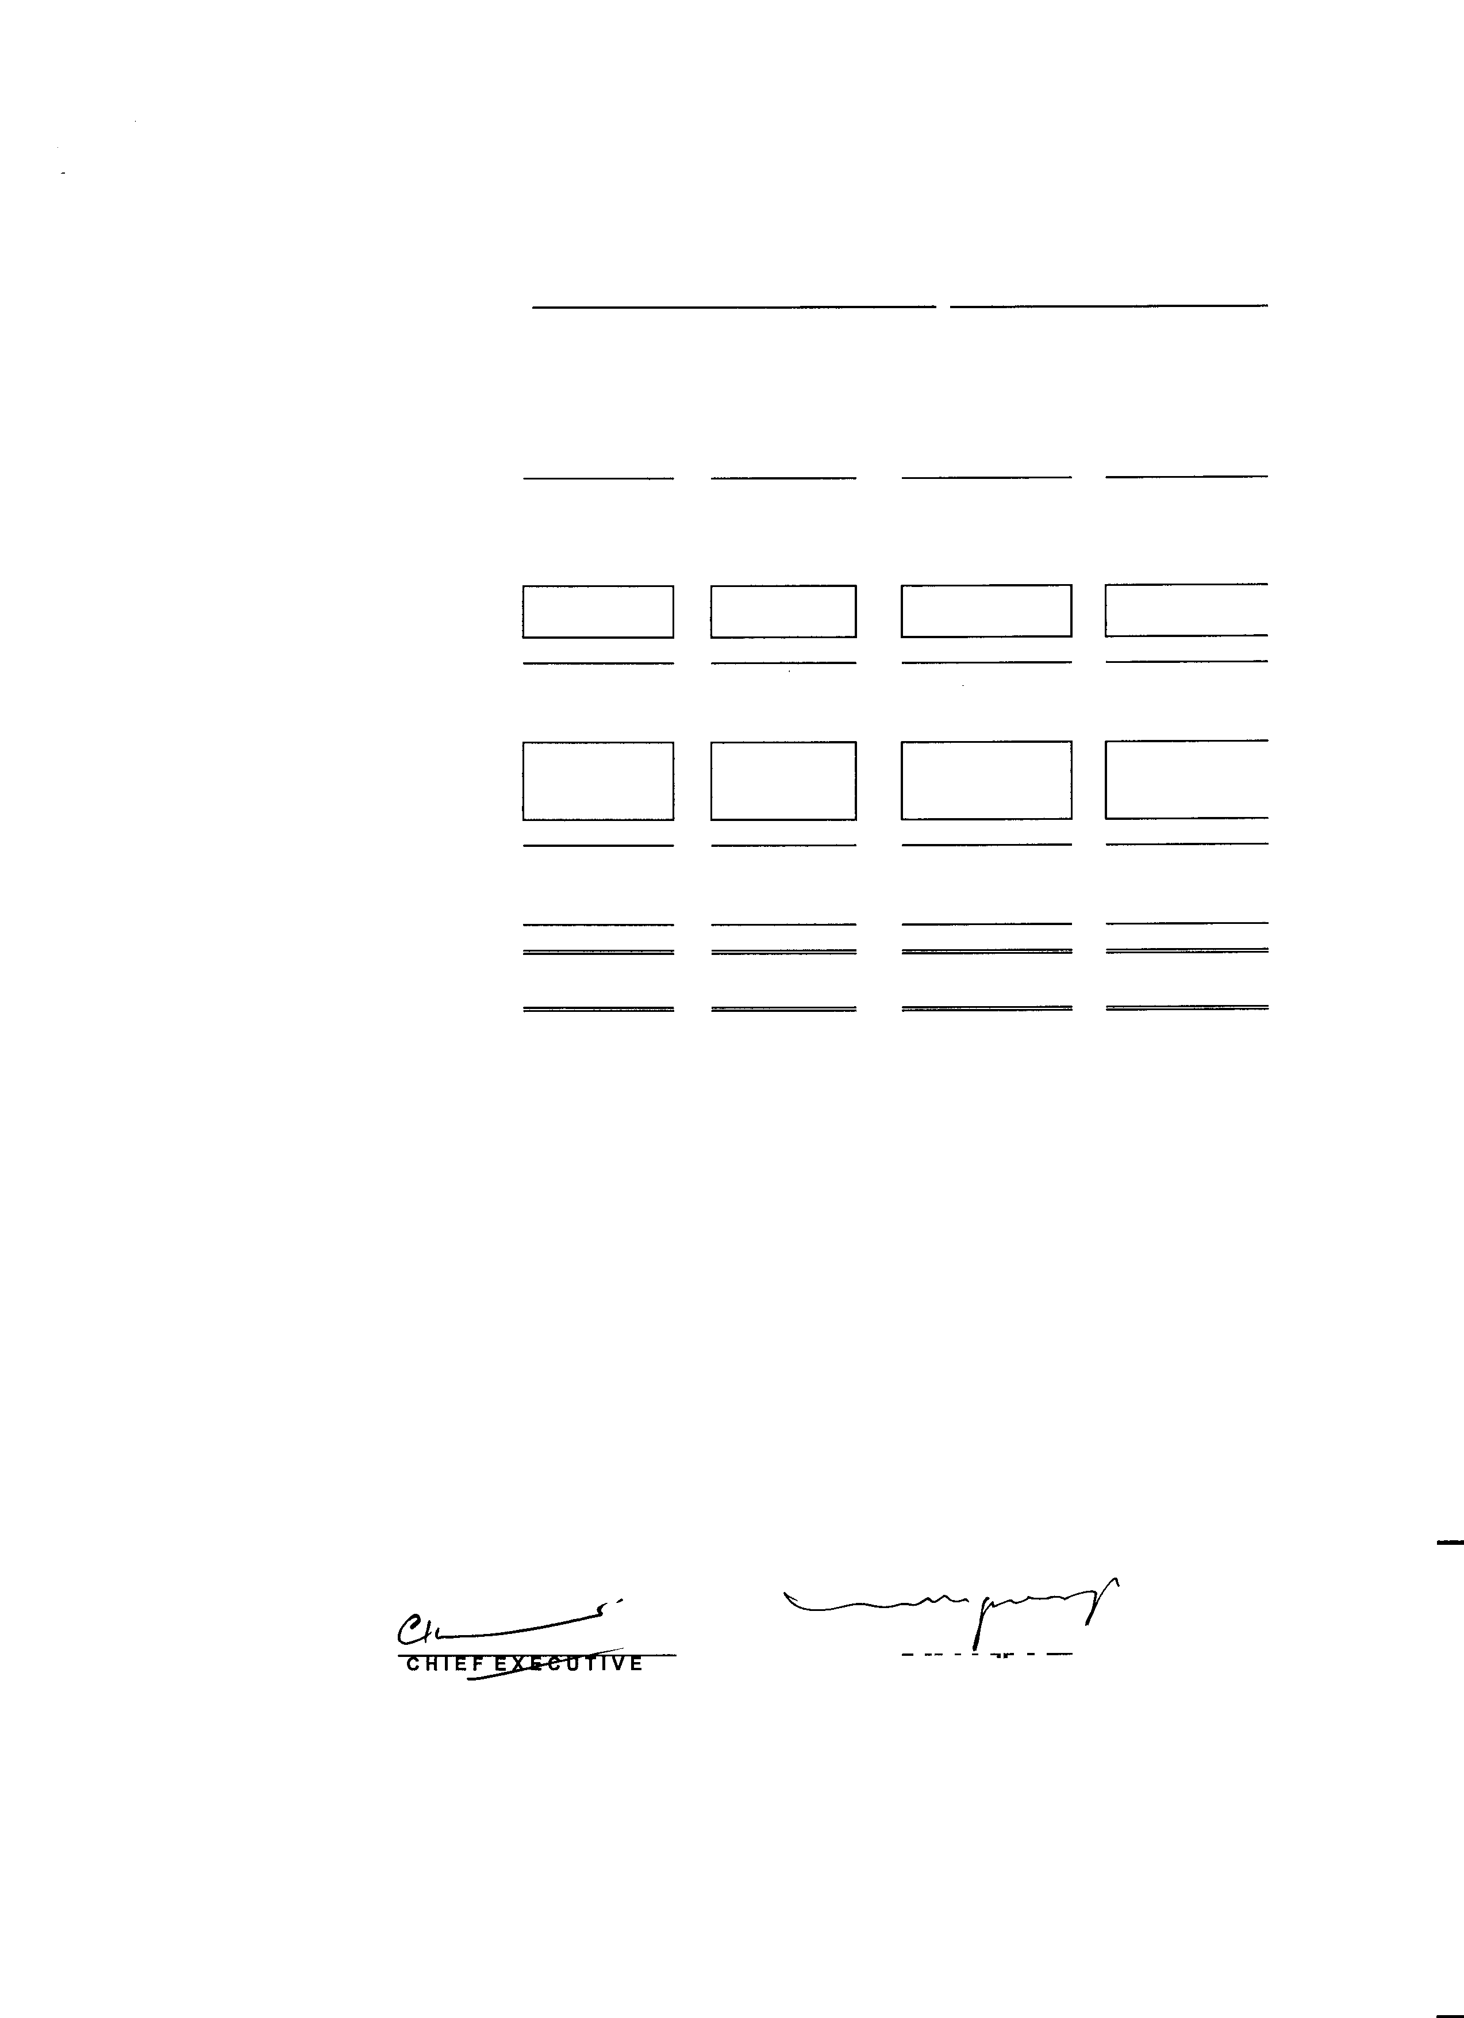

•

|  |  |  |  |  |  |
| --- | --- | --- | --- | --- | --- |
| COST OF SALES | 10 | (2,816,876, 766) | (2,996,989,358) | (1,483,091,788) | (1,548,814,746) |
| GROSS PROFIT |  | 223,861,189 | 415,841,868 | 52,051,048 | 192,082,238 |
| OPERATING EXPENSES |  |  |  |  |  |
| Distribution Cost |  | (82,357,501) | (80,995,535) | (50,036,774) | (41,117,048) |
| Administrative |  | (57,826, 158) | (70, 782,089) | (17,878,161) | (31,181,813) |
|  |  | (140, 183,659) | (151,777,624) | (67,914,935) | (72,298,861) |
| OPERATING PROFIT/(LOSS) |  | 83,677,530 | 264,064,244 | (15,863,887) | 119, 783,377 |
| Financial cost |  | (131,035,886) | (142,661,068) | (62, 721,627) | (80,884,466) |
| Other operating expense |  | - | (6,084,346) | 1,582,482 | (2, 142,945) |
| Other operating income |  | 27,358,731 | 283,750 | 26,936,259 | - |
|  |  | (103,677, 155) | (148,461,664) | (34,202,886) | (83,027 ,411) |
| (LOSS)/PROFIT BEFORE TAXATION |  | (19,999,625) | 115,602,580 | (50,066,773) | 36,755,966 |
| TAXATION | 11 | (30,407 ,380) | (34,128,312) | (15,351,429) | (17,408,970) |
| (LOSS)/PROFIT AFTER TAXATION |  | (50,407,005) | 81,474,268 | (65,418,202) | 19,346,996 |
| (LOSS)/EARING PER SHARE - BASIC | 12 | (0.39) | 0.63 | (0.50) | 0.15 |

The annexed notes form an integral part of these condensed interim financial information.

I

'

I Lahore,

February 28, 2015 bl REC I OR

•

KOHINOOR SPINNING MILLS LIMITED

CONDENSED INTERIM STATEMENT OF COMPREHENSIVE INCOME (UN-AUDITED)

FOR THE HALF YEAR ENDED DECEMBER 31, 2014

•

���....,_H�a�f�Ye�a�r�E�=�d�������QuarterEnded

**December 31,201•**

**December 31,2013**

**December 31,2014**

**December 31,2013**

(Loss)/Profit after taxation

Other Comprehansive income

Items that may be reclassified subsequently to profit and loss

Unrelized (loss) due to change in fair value of long term investment

Items that will not reclassified to profit and loss

(50,407,005)

•

(216,216)

•

81,474,268

•

(640,332)

•

(65,418,202)

•

(340,957)

•

19,346,996

•

(143,034)

•

Total comprehensive (Loss)/lncome

(50,623,221)

=====

80,833,936 (65,759,159) 19,203,962

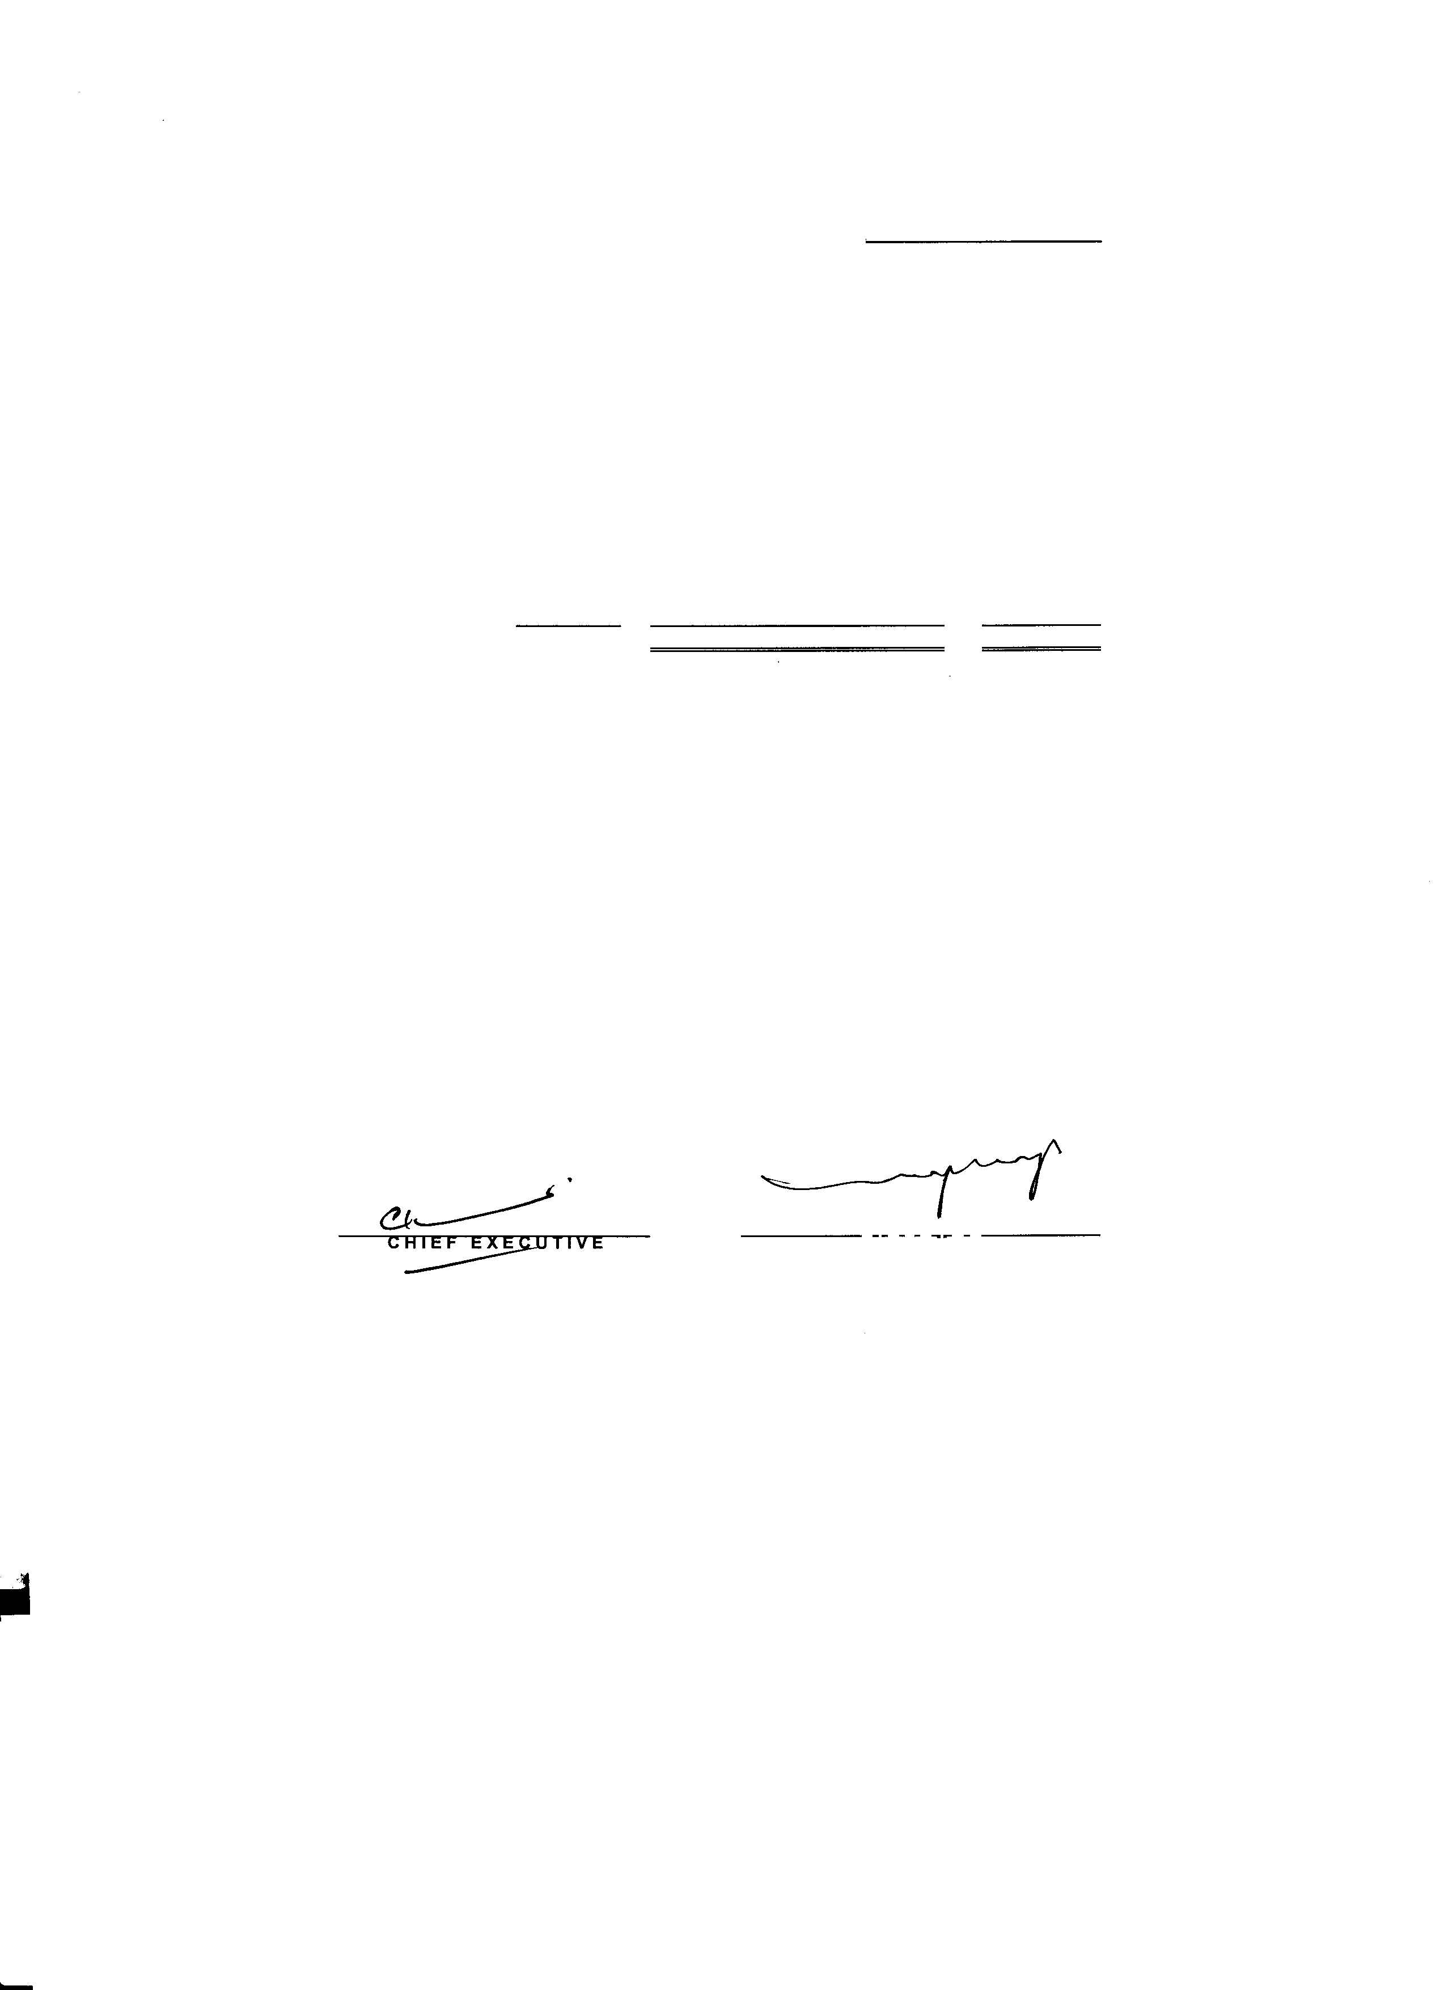

The annexed notes form an integral part of these condensed interim financial information.

•

'

Lahore,

February 28, 2015 **UIRECIOR**

-

KOHINOOR SPINNING MILLS LIMITED

CONDENSED INTERIM CASH FLOW STATEMENT (UN-AUDITED)

FOR THE HALF YEAR ENDED DECEMBER 31, 2014

•

Share Accumulated

Capital Profit Total

(Rupees) (Rupees) (Rupees)

Balance as at July 01, 2013

650,000,000

395,401,268 1,045,401,268

|  |  |  |  |
| --- | --- | --- | --- |
| Profit for the half year ended after taxation | • | 81,474,268 | 81,474,268 |
| Unrealized (loss) due to change in fair  Value of long tern, investment | • | (640,332) | (640,332) |
| Balance as on December 31, 2013 | 650,000,000 | 476,235,204 | 1, 126,235,204 |
| Balance as on July 01, 2014 | 650,000,000 | 488,020,366 | 1, 138,020,366 |
| (Loss) for the halt year ended after taxation | • | (50,407,005) | (50,407,005) |
| Dividend for the year 2013-2014 | • | (6,131,462) | (6,131,462) |
| Unrealised (loss) due to change in fair |  |  |  |
| value of long tenn investment | • | (216,216) | (216,216) |
| Balance as on December 31, 2014 | 650,000,000 | 431,265,683 | 1,081,265,683 |

The annexed notes form an integral part of these condensed interim financial information.

/

Lahore,

February 28, 2015

**CA IE F EXE** [! U I l"IV71=E,--- **DIREC I OR**

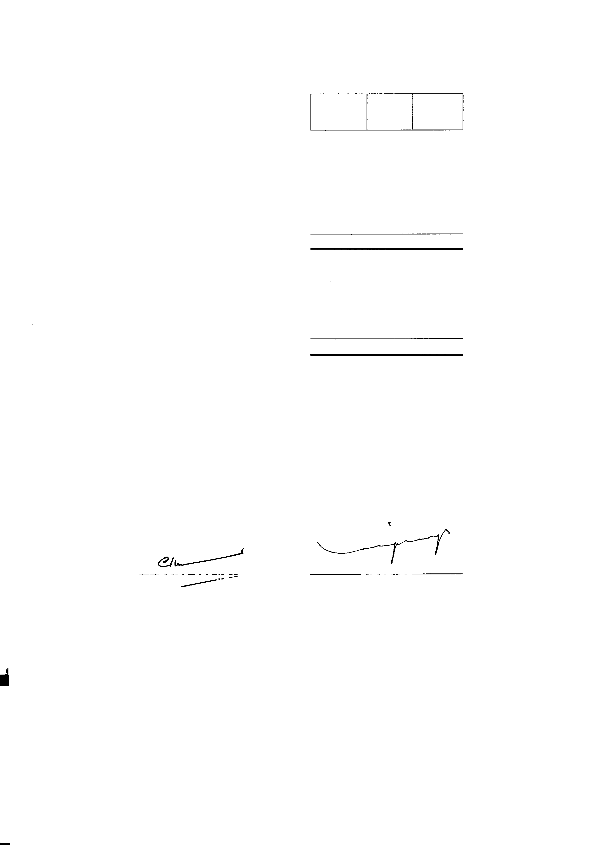

- •

-

KOHINOOR SPINNING MILLS LIMITED CONDENSED INTERIM CASH FLOW STATEMENT (UN-AUDITED)

FOR THE HALF YEAR ENDED DECEMBER 31, 2014

-

The annexed notes form an integral part of these condensed interim financial information.

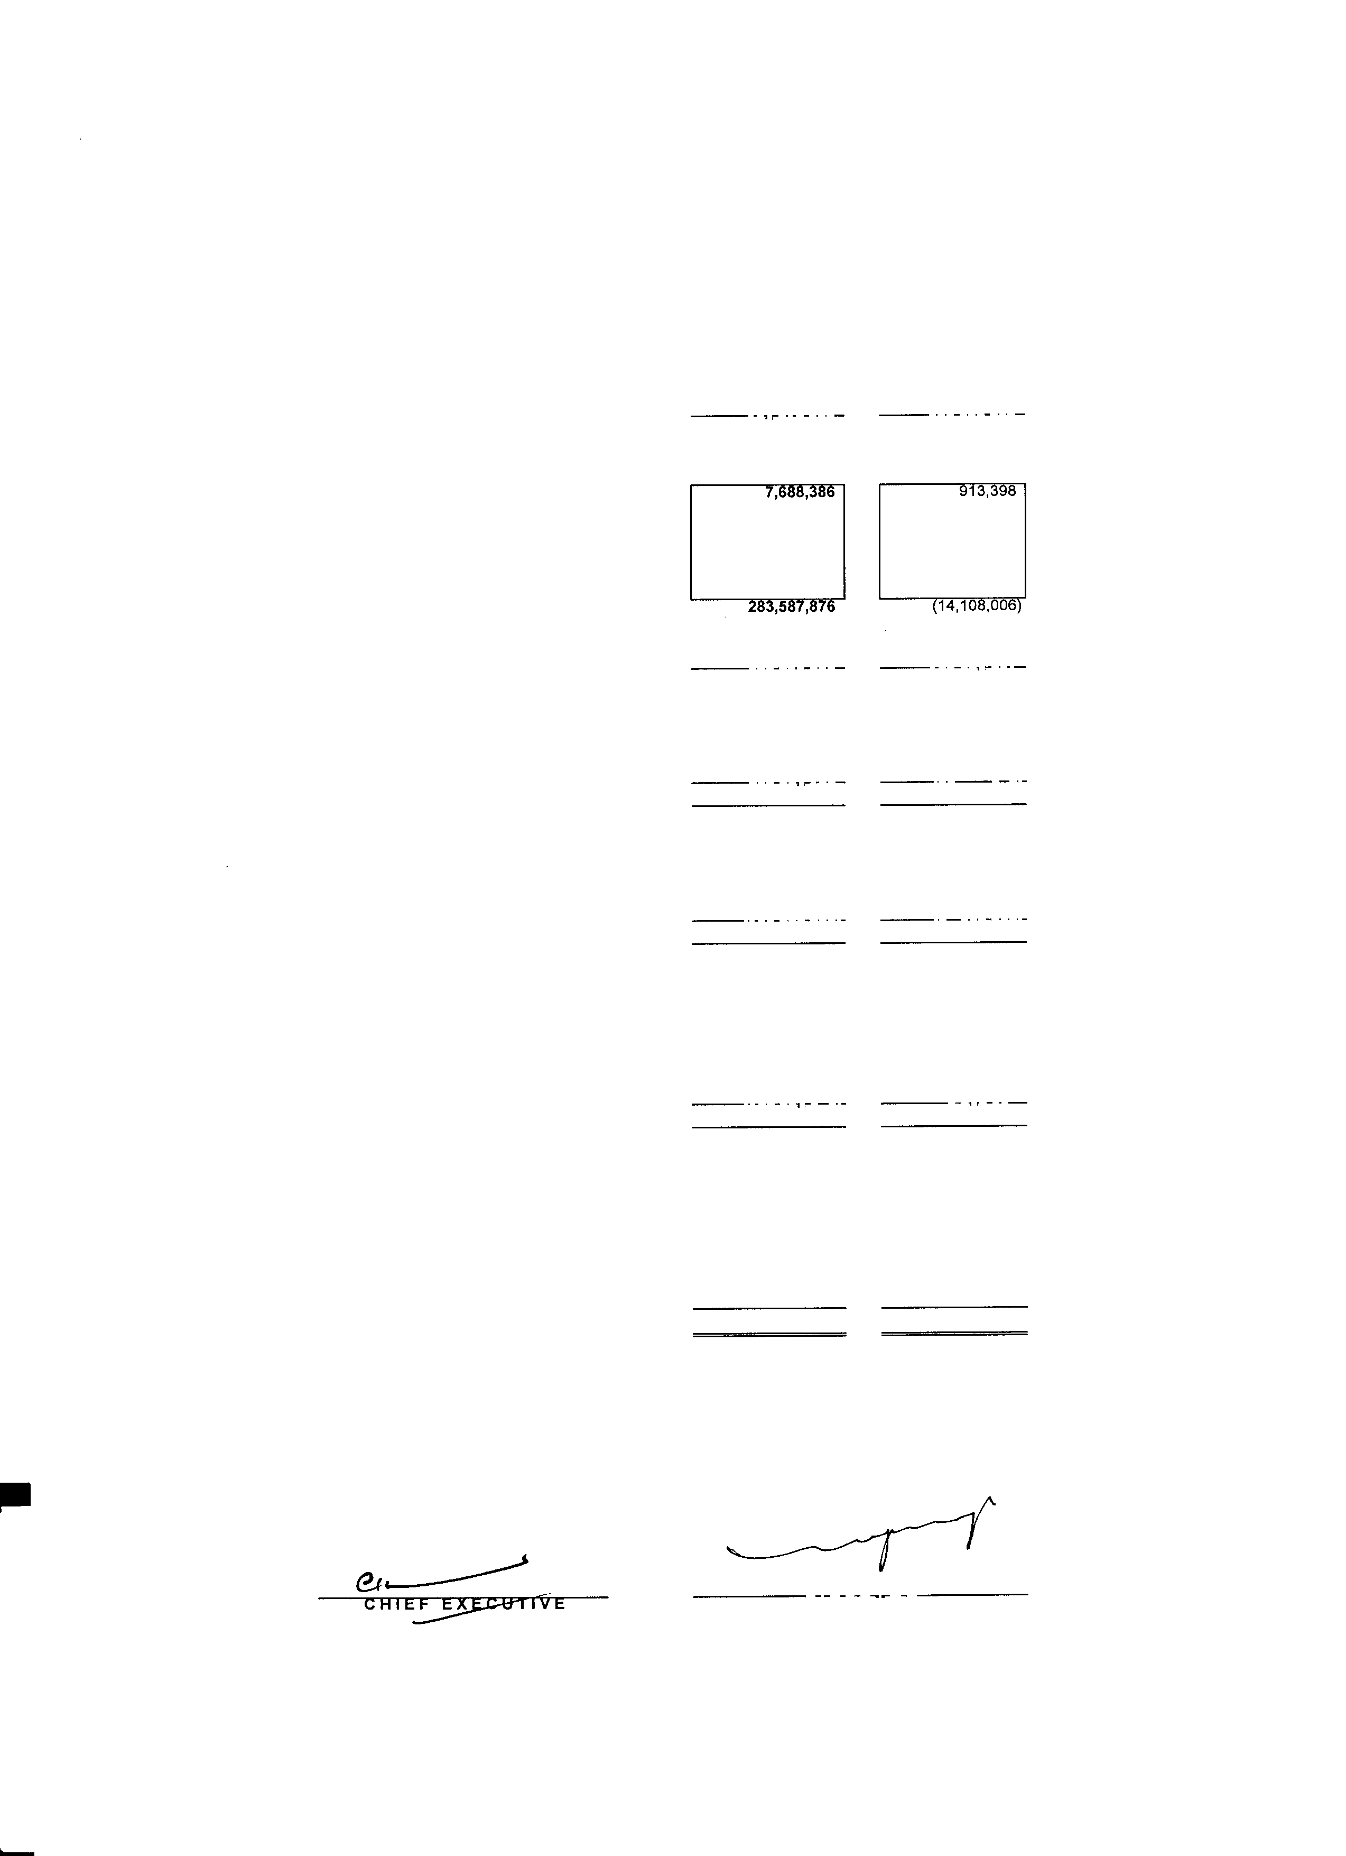

|  |  |  |  |
| --- | --- | --- | --- |
|  | | Un-Audited  December 31, 2014 | Un-Audited  December 31, 2013 |
| (Rupees) | (Rupees) |
| CASH FLOW FROM OPERATING ACTIVITIES |  |  |  |
| (Loss)/Profit before taxation |  | (19,999,625) | 115,602,580 |
| Adjustments of non cash charges and other items: |  |  |  |
| Depreciation *I* amortization |  | 47,469,459 | 50,681,749 |
| Gratuity |  | 20,302,338 | 16,696,987 |
| Gain on sale of fixed assets |  | (1, 189,086) | (283,750) |
| Financial cost |  | 131,035,886 | 142,661,068 |
| Operating profit before working capital changes |  | 17 *I* ,618,972 | 325,358,634 |
| (lncrease)/decrease in current assets |  |  |  |
| Stores and spares |  |  | 31, |
| Stock-in-trade |  | 269,315,928 | 20,989,178 |
| Trade debts |  | 7,473,906 | (37,555,436) |
| Loan & advances |  | 19,215,722 | (20,573, 155) |
| Trade deposits, prepayments & other receivables |  | (20, 106,066) | (8,881,991) |
| Increase in current liabilities  Trade and other payables |  | (63,517,646) | (153,673,047) |
|  |  | 397,689,202 | 157,57/,581 |
| Financial cost paid |  | (134,987,714) | (141,990,767) |
| Income tax paid |  | (28, 199,456) | (33,643,302) |
| Dividend paid |  | (5,910,560) | (33,643,302) |
| Gratuity paid |  | (8,324,305) | (8,414, 756) |
| Net cash used in operations |  | 220,261, 166 | (60, 114,547) |
| CASH FLOW FROM INVESTING ACTIVITIES Property.Plant & Equipment | • | (100, 166,077) | (91, 138,887) |
| Long term loans |  | (1,502,530) | (242, 143) |
| Proceeds from disposal property, plant and equipment |  | 1,600,000 | 575,000 |
| Net cash used in investing activities |  | (100,068,607) | (90,806,030) |
| CASH FLOW FROM FINANCING ACTIVITIES |  |  |  |
| (Repayments)/proceeds from: |  |  |  |
| Increase/Decrease in long term financing |  | 400,000,000 | (17,857, 145) |
| Decrease in finance lease liabilities |  | (17,349,017) | (9,240,850) |
| Decrease in supplier's credit |  | (107,912,840) | (39,038,866) |
| Decrease/Increase in short term borrowings  Net cash generated from financing activities |  | (395,326,091)  (120,58 *r* ,948) | 185,016, 199  118,8/9,338 |
| NET INCREASE/DECREASE IN CASH AND CASH EQUIVALENTS |  | (389,389) | 1,602,064 |
| CASH AND CASH EQUIVALENTS AT |  |  |  |
| THE BEGINNING OF THE PERIOD |  | 10,910,082 | 9,584,765 |
| CASH AND CASH EQUIVALENTS AT |  |  |  |
| THE END OF THE PERIOD |  | 10,520,693 | 11,186,829 |

-

-

Lahore,

February 28, 2015

'

DIREC I OR

**KOHINOOR SPINNING MILLS LIMITED**

**NOTES TO THE CONDENSED INTERIM FINANCIAL STATEMENS {UN-AUDITED) FOR THE HALF YEAR ENDED DECEMBER** 31, **2014**

- 1. NATURE AND STATUS OF BUSINESS

KOHINOOR SPINNING MILLS LIMITED was incorporated on 23rd July, 1970 as a public limited company in Pakistan under the Companies Ordinance, 1984 and is quoted on Karachi stock exchange. The registered office of the company is situated at 7/1, E/3, Main Boulevard Gulberg Ill, Lahore. The company is engaged in the business of textile spinning.

2. BASIS OF PRESENATION

This interim condensed financial statement is unaudited and are being submitted to the shareholders as required under section 245 of the Companies Ordinance, 1984. These interim condensed financial statements has been prepared in accordance with the International Accounting Standard 34 (Interim Financial Reporting). In case where requirment differ, the provisions of or directives issued under the Companies Ordinance, 1984 have been followed. These condensed interim financial statements should be read in conjunction with the audited annual published Financial statements of the company for the year ended June 30, 2014.

3. SIGNIFICANT ACCOUNTING POLICIES

The accounting policies and the the methods of computation adopted in the preparation of this condensed interim financial information are the same as those applied in the preparation of the preceding annual published financial statemends of the company for the year ended June 30, 2014.

Amendments to certain existing standards and new interpretation on approved accounting standards that become effective during the period either were not relevant to the Company's operations or did not have any significant

impact on the accounting policies of the Company.

4.

4.1

4.2

ACCOUNTING ESTIMATES, JUDGEMENTS AND FINANCIAL RISK MANAGEMENT

The preparation of this condensed interim financial information in conformity with approved accounting standards requires management to make estimates, assumptions and use judgements that affect the application of policies and reported amounts of assets and liabilites and income and expenses. Estimates, assumptions and judgements are continually evaluated and are based on historical experience and other factors, including reasonable expectations of future events. Revisions to accounting estimates are recognised prospectively commencing from the period of revision.

Judgments and estimates made by the management in the preparation of this condensed interim financal information are the same as those that were applied to the financial statements as at and for the year ended 30 June 2014.

The company's financial risk management objectives and policies are consistent with those disclosed in the financial statements as at and for the year ended 30 June 2014.

|  |  |  |  |
| --- | --- | --- | --- |
|  | | Un-Audited  December 31, 2014 | Audited  June 30, 2014 |
| 5. | SHARE CAPITAL | (Rupees) | (Rupees) |
|  | Issued, subscribed and paid up |  |  |
|  | 127,725,000 (June 30, 2014 -127,725,000) ordinary shares |  |  |
|  | of Rupees 5/- each, issued for cash | 638,625,000 | 638,625,000 |
|  | 2,275,000 (June 30, 2014 -2,275,000) ordinary shares of |  |  |
|  | of Rupees 5/- each, issued as bonus shares | 11,375,000 | 11,375,000 |
|  |  | 650,000,000 | 650,000,000 |
| 6. | COMMITMENTS |  |  |
|  |  | Un-Audited | Audited |
|  |  | December 31, 2014 | June 30, 2014 |
|  |  | (Rupees) | (Rupees) |

(i) Letter of credits for Import of raw material



(ii) Letter of credits machinary & parts

13. 722 Million

5.483 Million

26.945 Million

1 .461 Million

7. PROPERTY, PLANT AND EQUIPMENT

|  |  |  |
| --- | --- | --- |
|  | Opening writtendown value  Additions during the period | 7.1 |
| Transfer during the period | 7.2 |
| Deletion/transfer during the period | 7.3 |
| Depreciation charged during the period  Eliminated on desposal |  |
| LEASED |  |
| Opening writtendown value |  |
| Additions/transfer during the period |  |
| Deletion/transfer during the period |  |
| Amortization charged during the period |  |
| CAPITAL WORK IN PROGRESS |  |
| Plant and machinary |  |
| Civil works |  |
| 7.1 | ADDITIONS DURING THE PERIOD |  |

•

-

Un-Audited December 31, 2014 (Rupees)

Audited June 30, 2014 (Rupees)

92,725,673

|  |  |
| --- | --- |
| 1,608,864,503 | 1,513,846, 130 |
| 100, 166,077 | 224,840,680 |
| 278,233,037 | - |
| 1,987,263,617 | 1, 738,686,810 |
| {1,439,554) | (45,926,433) |
| 1,985,824,063 | 1,692, 760,377 |
| (43,963,789) | (83,895,874) |
| 1,028,640 | - |
| 1,942,888,914 | 1,608,864,503 |

-

92,725,673

-

92,725,673

(3,505,670)

89,220,004

52,472,554

45,969,203

98,441,757

-

98,441,757 (5, 716,084)

92,725,673

- 149,167,319

- 129,065,718

- 278,233,037

2,032, 108,918 1,979,823,212

Factory building on freehold land

Plant and machinary Electric installation Office equipment

Furniture and fixture • -

|  |  |
| --- | --- |
| 23,110,246 | 12,053, 159 |
| 75,259,255 | 205,346,246 |
| 1,726,675 | 4,240,313 |
| - | 659,962 |
|  | 175,000 |
| 69,900 | 2,366,000 |
| 100, 166,077 | 224,840,680 |

Vehicles

7.2 TRANSFER DURING THE PERIOD

Factory building on freehold land

Plant and machinary

7.3 DELETION/TRANSFER DURING THE PERIOD Plant and machinary

Vehicles

8. LONG TERM INVESTMENTS Held as available for sale

Others - Quoted

KASB Modaraba (Former First Mehran Modaraba)

166,320 modaraba certificates of Rupees 10 each.

- 9. STOCK-IN-TRADE

129,065, 718

149,167,319

278,233,037

|  |  |
| --- | --- |
| - | 44,815,403 |
| 1,439,554 | 1,111,030 |
| 1,439,554 | 45,926,433 |

Un-Audited December 31, 2014 (Rupees)

573,803

573,803

-

-

-

Audited June 30, 2014 (Rupees)

790,019

790,019

|  |  |
| --- | --- |
| 1,112,718,353 | 1,331,618,902 |
| 139,819,455 | 125,987,330 |
| 244,329,807 | 311,423,510 |
| 6,475,670 | 3,629,471 |
| 1,503,343,285 | 1, 772,659,213 |

-



Raw material Work-in-process Finished goods Waste

10. COST OF SALES

Half Year Ended

Quarter Ended

**December 31,2013**

**December 31,2014**

**December 31,2013**

**O.cember 31,2014**

Cost of goods manufactured

- Opening stock of finished goods

Cosing stock of finished goods

2,752,629,262

315,052,981 (250,805,477)

2,816,876,766

3, 142,072,724

216,047,220 (361, 130,586)

2,996,989,358

**1,476,528,948**

257 ,368,317 (250,805,477)

1,483,091,788

1,639,786,990

270, 158,342 (361,130,586)

1,548,814, 746

11. TAXATION

Un-Audited

December 31, 2014 (Rupees)

Audited June 30, 2014 (Rupees)

Opening balance

For the current period

Less: adjusted

Closing balance

11,313,375 4,696,724

30,407,380 16,719,342

41,720,755 21,416,066 (28, 199,456) (12,939,933)

13,521,299 8,476, 133

12. (LOSS)/EARNING PER SHARE • Basic

-��.......,H��f�Y�e�a��E�n�d��������guarterEnded

**December 31,2013**

**December 31,2014**

**o.cemt>er 31,2013**

**December 31,2014**

**(Loss)/Profit after taxation**

**Weighted average number of ordinary shares**

(Loss)/Eaming per share - Basic

12.1 Diluted earing per share

(50,407,005)

130,000,000 (0.39)

81,474,268

130,000,000

0.63

(65,418,202)

130,000,000 (0.50)

19,346,996

130,000,000

0.15

There is no dilution effect on the basic earing per share of the company as the company has no such commitments .

13. TRANSACTION WITH RELATED PARTIES

•

December 31, 2014

(Rupees)

December 31, 2013 (Rupees)

The transactions between the company and related parties are at arm's lenght prices determined in accordance with comparable uncontrolled price method. The company during the period ending December 31, 2014 entered to

following transactions with its related parties:

Sale of material and goods (Yousaf Weaving Mills Ltd.)

3,216,060 12,856,822

14. AUTHORISATION FOR ISSUE

These condensed interim Financial statement have been authorised for issue on February 28, 2015 by the Board of

Directors of the company.

15. GENERAL

Figures have been rounded off to the nearest rupee.

- Lahore,

/

*<21*

OIRECIOR -

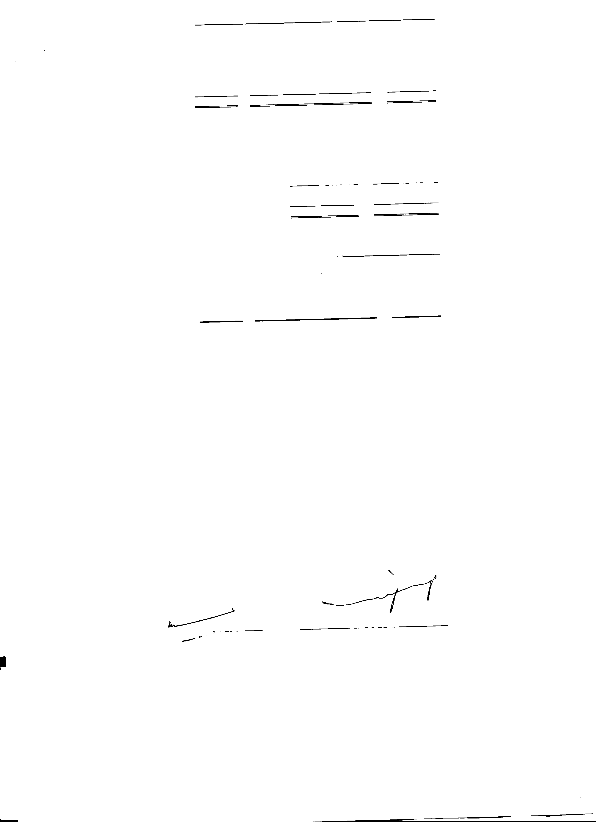

February 28, 2015

--,cl"'"tAJT-.:E,f,,--.:E-ixr=C u<1 I V E